Введите число: 1

Traceback (most recent call last):

File "C:\Users\ИСП-21\pythonProjectpda\zay\1.py", line 4, in <module>

total = total + rest

NameError: name 'total' is not defined

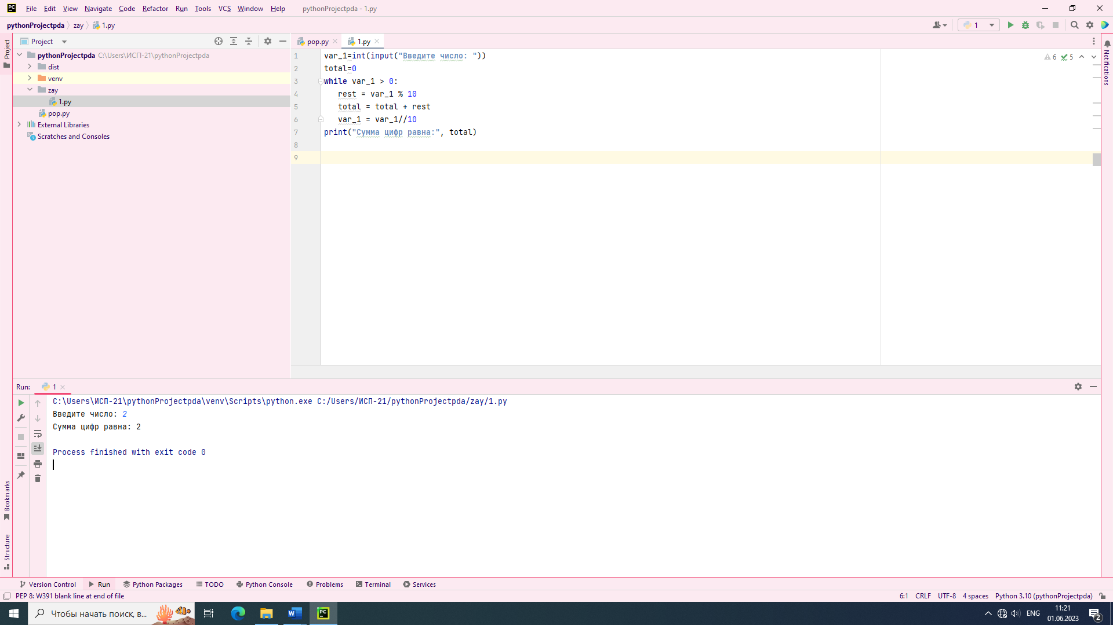

PS C:\Users\ИСП-21\pract> python -m cProfile 1.py

Введите число: 6

Сумма цифр равна: 6

5 function calls in 2.756 seconds

Ordered by: standard name

ncalls tottime percall cumtime percall filename:lineno(function)

1 0.000 0.000 2.756 2.756 1.py:1(<module>)

1 0.000 0.000 2.756 2.756 {built-in method builtins.exec}

1 2.756 2.756 2.756 2.756 {built-in method builtins.input}

1 0.000 0.000 0.000 0.000 {built-in method builtins.print}

1 0.000 0.000 0.000 0.000 {method 'disable' of '_lsprof.Profiler' objects}